Title of Your Contribution to AIC International Congress 2027: Template for Papers
Name SURNAME,ª Name SURNAME,ª Name SURNAME^{b}
ªFirst Institution, Country.
^{b}Second Institution, Country.
Corresponding Author: correspondingauthor@xxx.xx

ABSTRACT
The abstract of the full paper must be submitted in English, with an extension between 150 and 300 words, be in just one paragraph justified, and use no first line indents. The abstract should briefly summarize the paper structure: introduction, objectives, methodology, results, discussion and conclusions. Lorem ipsum dolor sit amet, consectetuer adipiscing elit. Maecenas porttitor congue massa. Fusce posuere, magna sed pulvinar ultricies, purus lectus malesuada libero, sit amet commodo magna eros quis urna. Nunc viverra imperdiet enim. Fusce est. Vivamus a tellus. Pellentesque habitant morbi tristique senectus et netus et malesuada fames ac turpis egestas. Proin pharetra nonummy pede. Mauris et orci. Aenean nec lorem. In porttitor. Donec laoreet nonummy augue. Suspendisse dui purus, scelerisque at, vulputate vitae, pretium mattis, nunc. Mauris eget neque at sem venenatis eleifend. Ut nonummy. Fusce aliquet pede non pede. Suspendisse dapibus lorem pellentesque magna. Integer nulla. Donec blandit feugiat ligula. Donec hendrerit, felis et imperdiet euismod, purus ipsum pretium metus, in lacinia nulla nisl eget sapien. Donec ut est in lectus consequat consequat. Etiam eget dui. Aliquam erat volutpat. Sed at lorem in nunc porta tristique. Proin nec augue. Quisque aliquam tempor magna. Pellentesque habitant morbi tristique senectus et netus et malesuada fames ac turpis egestas. Nunc ac magna. Maecenas odio dolor, vulputate vel, auctor ac, accumsan id, felis. Pellentesque cursus sagittis felis. Pellentesque porttitor, velit lacinia egestas auctor, diam eros tempus arcu, nec vulputate augue magna vel risus. Cras non magna vel ante adipiscing rhoncus. Maecenas porttitor congue massa. Fusce posuere, magna sed pulvinar ultricies, purus lectus malesuada libero, sit amet commodo magna eros quis urna. Nunc viverra imperdiet enim. Fusce est. Vivamus a tellus. Pellentesque habitant morbi tristique senectus et netus et malesuada fames ac turpis egestas.

Keywords: colour, architecture, heritage, city center (up to five, separated by semicolons, and without a period at the end)

1. INTRODUCTION
Full text must be between 2,500 and 3,500 words, including abstract, references, figures and captions, and a maximum length of 8 pages. Authors will send their full contribution before March 29, 2027. Authors are fully responsible for their contributions, which should not have been published elsewhere and for obtaining permission to use any material that might be protected by copyright. Authors will indicate the thematic area for the contribution. All papers will be blind peer-reviewed by the Scientific Committee. All accepted contributions will appear in the conference proceedings. A selection of contributions from those accepted, will be invited to be presented in the corresponding thematic session. Others accepted but not selected for oral presentation will be invited to contribute to the poster session. Poster will be scheduled in the corresponding poster session.
The second and next paragraphs in a section will be indented. Submissions imply the willingness of at least one author per paper to attend the conference, and present the paper. Accepted papers must be presented in-person (virtual or remote presentations are not considered). For each contribution published in the proceedings book, at least one author must be registered to the congress. Each registration entitles the author to publish one contribution. In the case of authors with multiple co-authored contributions, a different person must be registered for each paper. Selected contributions to the conference might be invited to publish a full paper (extended version) in some of the research journals edited at ETSA-UPV: EGA: Expresión Gráfica Arquitectónica; Loggia, Arquitectura y Restauración; En Blanco: Revista de Arquitectura; VLC arquitectura; LC: Revue de recherches sur Le Corbusier; Anuari d’Arquitectura i Societat.
The list of topics or thematic areas in this conference is: 1) Color in Architecture and Design, 2) Color in Arts and Culture, 3) Color in Restoration, 4) Color and digital rendering, 5) Multispectral Imaging, 6) Color Technology, 7) Color Science, 8) Color vision and perception, 9) Color in illumination and lighting, 10) Color and Education, 11) Color and Food.

2. LAYOUT
2.1. Length of the Paper
Full text must be between 2,500 and 3,500 words, including abstract, references, figures and captions, and a maximum length of 8 pages. File size is strictly limited to 10MB. Authors should optimize graphics (i.e. size and resolution appropriate for this format). Graphic resolution should not be any lower that 150 dpi for print quality. Separate images might be requested for proceedings edition.

2.2. Margins and organization of the paper
Papers should have a 2.5 cm margin on the top and the bottom, 3 cm margin on the right and the left, following this template. Footnotes should be avoided as much as possible and just be used in exceptional cases to add brief observations, clarifications, or digressions that would interrupt the flow of the main text. The paper should be organized in sections consecutively numbered using Arabic numerals and decimals. Both sections and subsections should be preceded with a single blank line.

2.3. Structure of the paper
The recommended structure for the text is the usual for an academic paper: introduction with a literature review and objectives, methodology, results, discussion, conclusions, acknowledgements and references.

2.4. Font size and format
Text should be written using Times New Roman typeface and sizes as used in this document. Should you emphasize some words, use italics rather than underline or bold styles. Do not use upper case other than for first letter of the title, names, units of measurement (if appropriate) and entire chapter headings.

2.5. Paragraph format
Paragraphs immediately following their headings must be justified on both sides with no indents for first lines. The document should use single-line spacing throughout.

2.6. Quotations
Quotations shorter than 15 words “should be given within the body of text and enclosed in quotation marks” (Albers, 2018, p. 18). Where a quotation is longer than 15 words, it should be given its own paragraph, indented by 1 cm left and justified on both sides. Quotation marks should not open or close such quotations. Indented quotations should be in Times New Roman 9pt. There should be a blank line between the preceding and following paragraphs.

Here is an example of how it should look. Lorem ipsum dolor sit amet consectetur adipiscing elit nec, sollicitudin nisi porttitor vivamus sem ultricies eleifend euismod, magnis primis tortor hendrerit class etiam platea. Eget fames litora id est nec erat convallis, blandit et duis vitae mauris lobortis, enim ad facilisis venenatis iaculis porta. Ultrices aliquet malesuada faucibus molestie venenatis risus, volutpat urna suspendisse etc. (Gage, 1999, pp. 15–16)

2.7. Figures: drawings and photographs
Illustrations should be located close to their corresponding text. Illustrations should be clear and legible when printed. All drawings and photographs must have an in-text call that makes reference to one figure (fig. 1) or two and more (figs. 2, 3). Every figure needs a caption to understand the content of the illustration without referring to the text. Lettering of the caption should be Times New Roman 8pt. In the case that the authors of the figure are different from the authors of the contribution, captions should include the source of the image. Single blank lines should precede and follow the image. Images and captions will be aligned in the center.

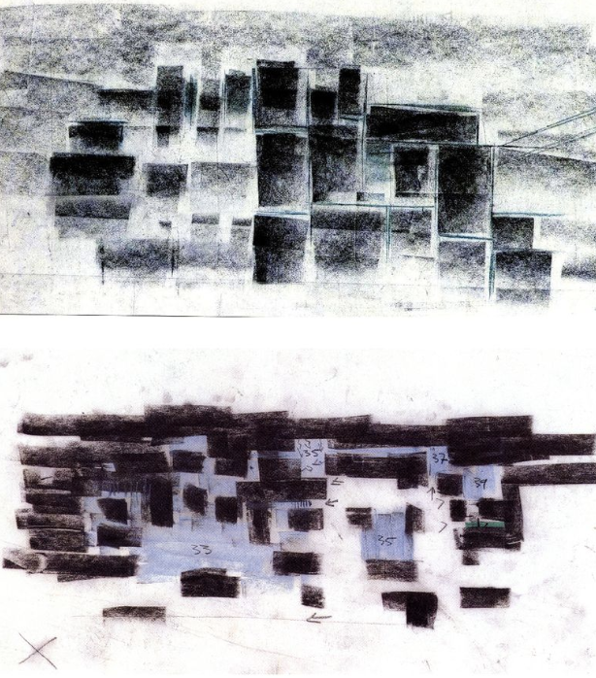
Figure 1. Top: Plan sketches illustrating the importance of solid and void 1st version. Bottom: 2nd version. Peter Zumthor, Vals Thermal Baths, Canton of Grisons (Switzerland), 1993–1996. (Source Negri, Andrea, in https://i.pinimg.com/originals/01/db/04/01db04ff3e81e6d6ee6b2f6851746c2d.png. Visited 10/06/26)

2.8. Tables
All tables should be consecutively numbered and adequately captioned. Their placement should be as close as practical to the relevant part of the text (table 1). Those tables not assembled by the author/s should have their source given in the title. Use single blank lines before and after the table. We recommend the use of the Times New Roman size 9 pt. and just horizontal lines.

Table 1. Tables should be centered on the page (Source: Albers, 218, p. 20)
Glazing type |  | U-value [W/m²K]
Glazing type |  | out | in
Clear+clear |  | 0,42-0,61 | 169-192
Clear+low-e |  | 0.23-0.52 | 133-157
Clear+tinted | grey | 0,49-0,60 | 74-152
 | bronze | 0,49-0,60 | 76-152
 | blue | 0,49-0,58 | 120-154
Clear+coated | silver | 0,39-0,48 | 36-59
 | blue | 0,42-0,46 | 58-73
 | copper | 0,29-0,30 | 44

2.9. Equations
Equations should begin from the left margin, with one blank line above and one below to separate them from text. Equations should be numbered consecutively with the number in brackets justified on the right-hand margin. They will be referenced in the text as Eq. (1), where 1 is the number of the referenced equation. For example,

V(r)=r²+B (1)

Symbols should be defined upon first use.

2.10. Units
The committee recommends use of SI units of measurement. Other units (e.g. American) are permissible only following the SI units and then must be given in parentheses, for instance, 404kPa (58.6psi) or 63.7m² (685.7ft²).

3. REFERENCES
The texts will use author-date citation system using APA style. In this system, each work used in a paper has two parts: an in-text citation and a corresponding reference list entry (Sato, 2007). In-text citations may be parenthetical or narrative. In parenthetical citations, use an ampersand (&) between names for a work with two authors or before the last author when all names must be included to avoid ambiguity (Delcampo-Carda, Torres-Barchino & Serra-Lluch, 2019). In narrative citations, always spell out the word “and.” I.e. …according to Delcampo-Carda, Torres-Barchino and Serra-Lluch (2019) colours are important in architectural environments.
Quotations should include the page number after comma (Caivano, 2006, p. 25). Footnotes may not be used to indicate references. When multiple sources are cited in the same sentence, they are separated by semi colons (Franco Taboada, 2015; Fridell Anter, 2000; Schindler, 2005).

4. EDITORIAL CHANGES
The editors reserve the right to adjust the format of the submitted text as required in the publishing process.

5. CONCLUSION
Each paper must be submitted as a “.doc” file through the Easy Chair platform following this link and before March 29, 2027 https://easychair.org/conferences/?conf=aic2027

ACKNOWLEDGEMENTS
In this section, authors can include any reference to founding agencies.

REFERENCES

All sources referred to in the text should be listed in alphabetical order, following the APA Style 7th edition.
Albers, A. (2018). Josef Albers: Interaction (H. Liesbrock & U. Growe, Eds.). Yale University Press.
Caivano, J. L. (2006). Research on color in architecture and environmental design: Brief history, current developments, and possible future. Color Research and Application, 31(4), 350–363.
Delcampo-Carda, A., Torres-Barchino, A., & Serra-Lluch, J. (2019). Chromatic interior environments for the elderly: A literature review. Color Research and Application, 44(3). https://doi.org/10.1002/col.22358
Franco Taboada, J. A. (2015). From Goethe’s theory of colours to Albers’ interaction of colour. EGA Revista de Expresion Grafica Arquitectonica, 20(25), 48–55. https://doi.org/10.4995/ega.2015.3703
Fridell Anter, K. (2000). What colour is the red house? Perceived colour of painted facades. (Vol. 1). Ed. Royal Institute of Technology, School of Architecture, Department of Architectural Forms.
Gage, J. (1999). Color and meaning : art, science, and symbolism. University of California Press.
Sato, M. (2007). Intergenerational Study on Image of Color concerning Interior Elements in a Living Space. In G. Ye & H. Xu (Eds.), AIC Color 2007, Proceedings (pp. 304–307). Color Association of China.
Schindler, V. M. (2005). Colour as vocation: Werner Spillmann’s contribution to environmental colour design. Color Research and Application, 30(1), 53–65. https://doi.org/10.1002/col.20075

This is an example of a footnote, to be used just in exceptional situations. The in-text call for the footnote is typically placed at the end of the sentence and after the colon.

